28th April 2025

Dear Parents/Carers,

We are pleased to be able to offer our Teacher-led clubs again this Term.

Please see attached a list of all clubs available for the Summer Term. Teacher led clubs will commence on Thursday 8th May 2025 and will run up until the week ending Friday 11th July 2025. Please note that there is no clubs on Thursday 1st May due to the school being closed for Inset Day.

We ask for a contribution towards the running of school clubs. Parents of children attending school clubs are asked to pay £3 per child/per week via ParentPay to sign up for clubs. The cost for the Summer Term is £24.

The children are expected to attend clubs each week, unless there are extenuating circumstances which are notified to us in writing. If a child does decide to leave a club they will not be able to join another one until the following term. Please note that children will be allocated to teacher-led clubs for the whole term.

We use ParentPay to sign up for and pay for clubs. This will be made available from 7pm on Wednesday 30th April. Please note that places are limited for some clubs and will be allocated on a first come first served basis. Should a club become full it will no longer appear on ParentPay.

Please Note: Ensure you choose your club wisely, as we are unable to swap club places and please only book onto 1 club. Booking onto 2 club limits the spaces available and can prevent another child from joining a club of their choice. If 2 clubs are booked then your child will be allocated the club which was booked first.

A variety of exit doors will be used to leave school after clubs, please check the list overleaf, and collect your youngest child first.

Regards
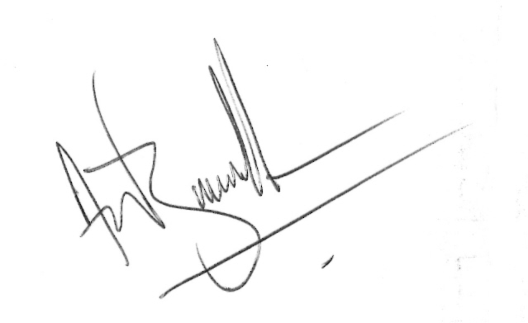
Andy Buckler
Headteacher

Torkington Primary School, Torkington Road, Hazel Grove, Stockport, Cheshire. SK7 6NR
Stationery donated by Stealth Intelligence Ltd

