

Headteacher: Andy Buckler
andy.buckler@torkington.stockport.sch.uk
School office: 0161 483 2188
schooladmin@torkington.stockport.sch.uk
www.torkington.stockport.sch.uk

Video Gaming Advice for Parents
Torkington Primary School is committed to keeping children safe and to promoting the safe, responsible use of technology. As such, we feel it is our responsibility to make you aware of the following.
Many children have been discussing video games that they have access to and play at home, including Grand Theft Auto, Call of Duty, Slender Man, Granny and Fortnite. All of these games have a UK age rating of 13 -18+ showing the content of these games is not appropriate for your children.

Ratings denote the content and appropriateness of games 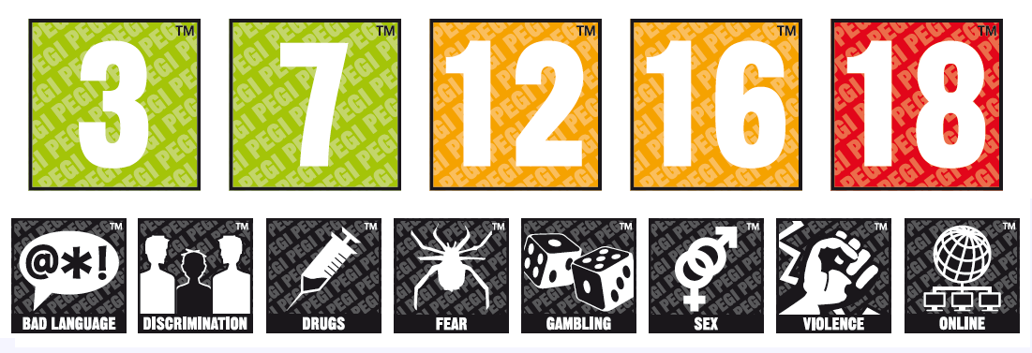
Games are age-rated under the Pan-European Game Information (PEGI).

All video games are rated for age on the packaging or as part of the listing on the App Store. Ratings do not show the difficulty of a game, but inform you that it contains content suitable for a certain age group and above.

It is important to note that the age ratings 12, 16 and 18 age ratings are mandatory and that it is illegal for a retailer to supply any game with any of these ratings to anyone below the specified age.

An 18 Rated game is usually contains at least one of the following - violence, explicit sexual activity (which may mean that genitals are visible) or activities that glamorises the use of real life drugs.

In addition to age ratings, video games will include indicators of the type of content and activities that the game includes in it.

The following websites contain detailed reviews so you know exactly what each game involves.

http://www.askaboutgames.com/advice/

https://www.commonsensemedia.org/

Popular Game Ratings
Fortnite - PEGI 12 for frequent scenes of mild violence. It is not suitable for persons under 12 years of age.
In addition, Fortnite involves lots of communication with other players online. This comes with it’s own range of issues about sharing information and keeping children safe online.

Granny – PEGI 12 for frequent scenes of violence. It is not suitable for persons under 12 years of age.
This game involves a corpse-like granny who chases you around the house with a blood covered bat. Cannibalism is implied, with pools of blood and a hunk of hanging raw meat. This is not suitable for your children.

Slender Man - PEGI 12 for frequent scenes of mild violence. It is not suitable for persons under 12 years of age.
This game is based on the suspenseful imagery of the faceless Slender Man who appears across many different stories. Some stories feature him stalking, abducting or traumatising young children. Most game versions involve him driving you insane the closer you get. The upcoming film will be rated 18.

Grand Theft Auto –PEGI 18 for extreme violence; multiple, motiveless killing; violence towards defenceless people; and strong language, scenes of torture, sexual activity and illegal drug use. It is not suitable for persons under 18 years of age to play or watch others playing.

Call of Duty – PEGI 18, for extreme violence, multiple motiveless killing and strong language including sexual expletives and depictions of battlefield injuries including decapitation, dismemberment and mutilation.

Some of these games above appear as “pop-ups” whilst your children are using technology in your homes. Pop-ups usually come when you download the free apps, it is important that you supervise your children when they are on their tablets or phones.

Sadly, recently many of your children tell us that they are playing these games, quite often without your knowledge. Access, to these and similar “games” whether this be playing them personally or watching adults at home play them can seriously affect your child. Children who have access to such content can develop mental health issues, develop behavioural difficulties, struggle with sleeping and concentration.

We feel it is important to point out to parents the risks of underage use of such video games, so you can make informed decisions on how to supervise your child’s access to
todays’ technology and prevent them from accessing such content.

Kind Regards

Andy Buckler

