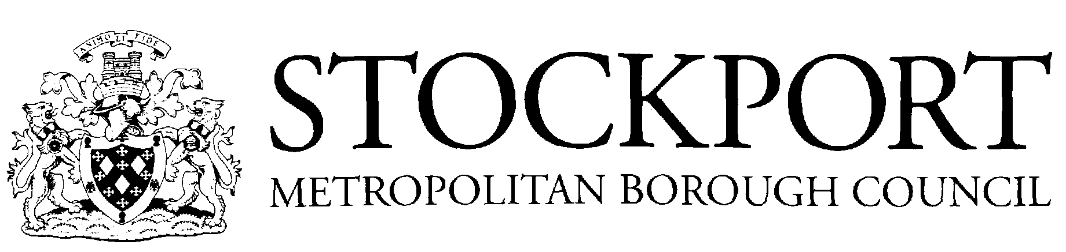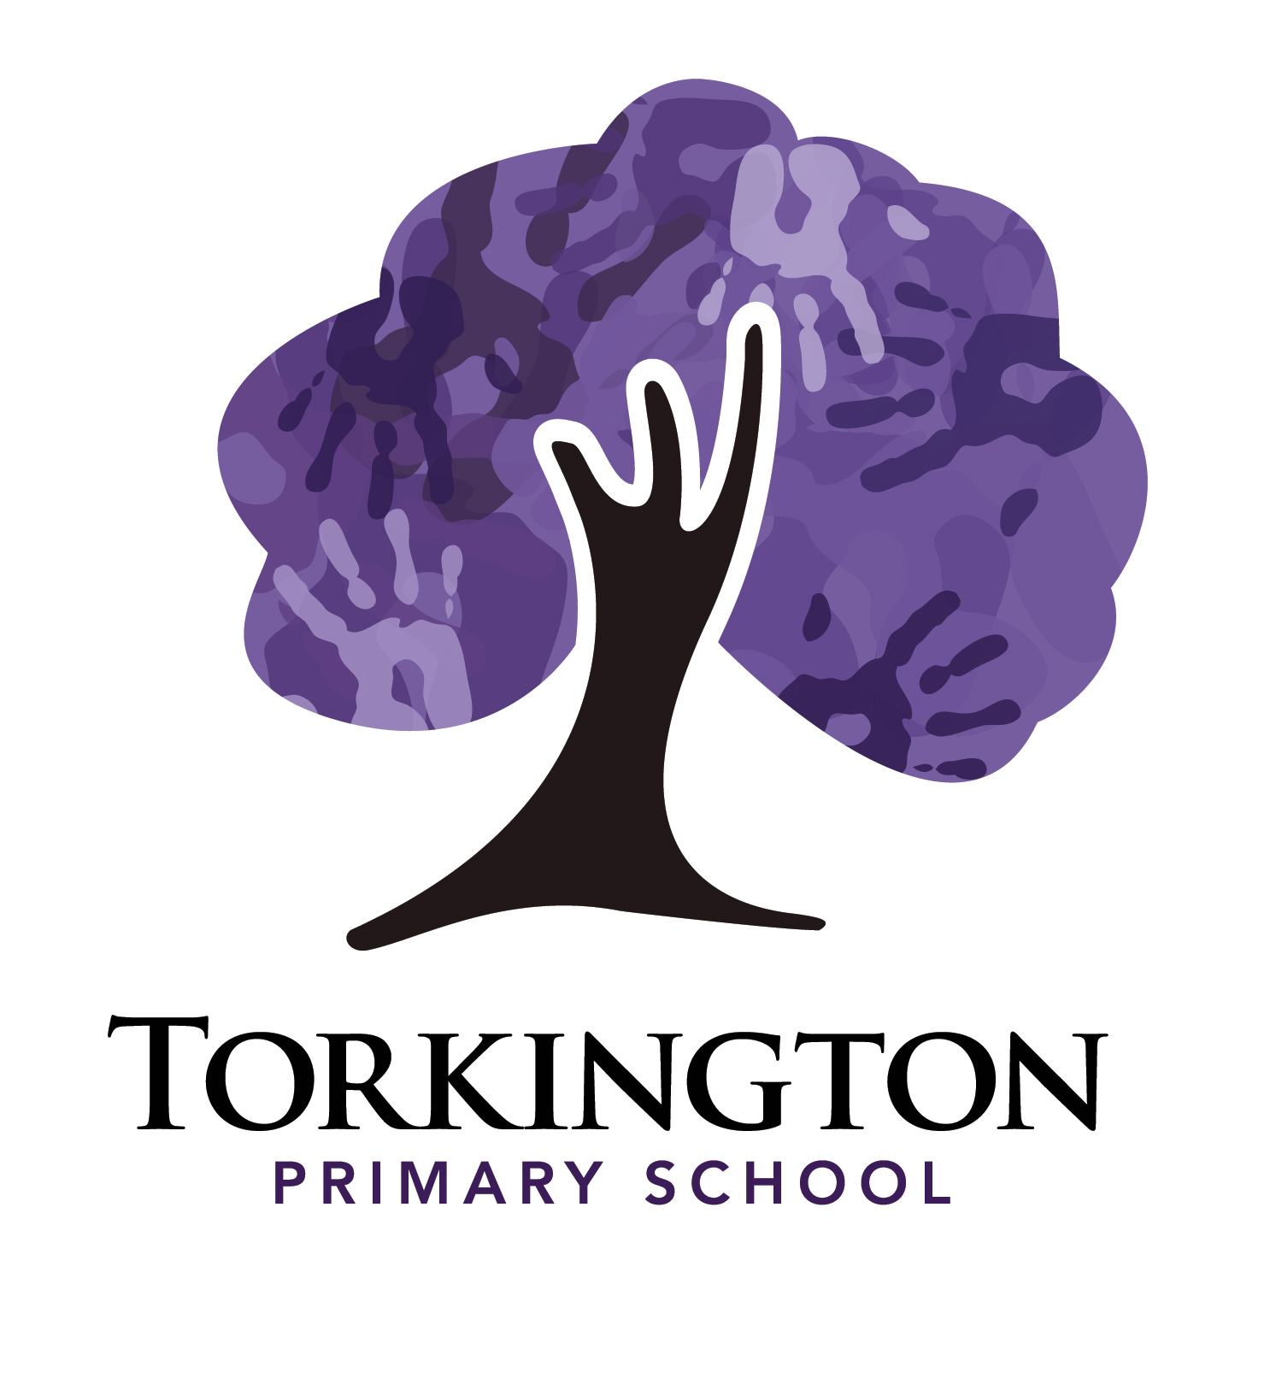

School Year 2026/2027

Autumn Term 2026
- Term Begins – Tuesday 1st September 2026
- Half-Term Holiday - Monday 26th October 2026 to Friday 30th October 2026 (inclusive)
- Term Ends – Friday 18th December 2026
- Christmas Holiday 2026/2027 – Monday 21st December 2026 to Friday 1st January 2027 (inclusive)
Spring Term 2027
- Term Begins – Monday 4th January 2027
- Half-Term Holiday - Monday 15th February 2027 to Friday 19th February 2027 (inclusive)
- Term Ends - Thursday 25th March 2027
- Easter Holiday 2027 – Tuesday 30th March 2027 to Friday 9th April 2027 (inclusive)
Summer Term 2027
- Term Begins – Monday 12th April 2027
- Half-Term Holiday – Monday 31st May 2027 to Friday 11th June 2027 (inclusive)
- Term Ends – Tuesday 27th July 2027
- Summer Holiday 2027 - Begins Wednesday 28th July 2027

Public Holidays
- Good Friday - Friday 26th March 2027
- Easter Monday - Monday 29th March 2027
- May Day – Monday 3rd May 2027
- Spring Bank Holiday – Monday 31st May 2027

Inset Days

TBC

