Magic Letters
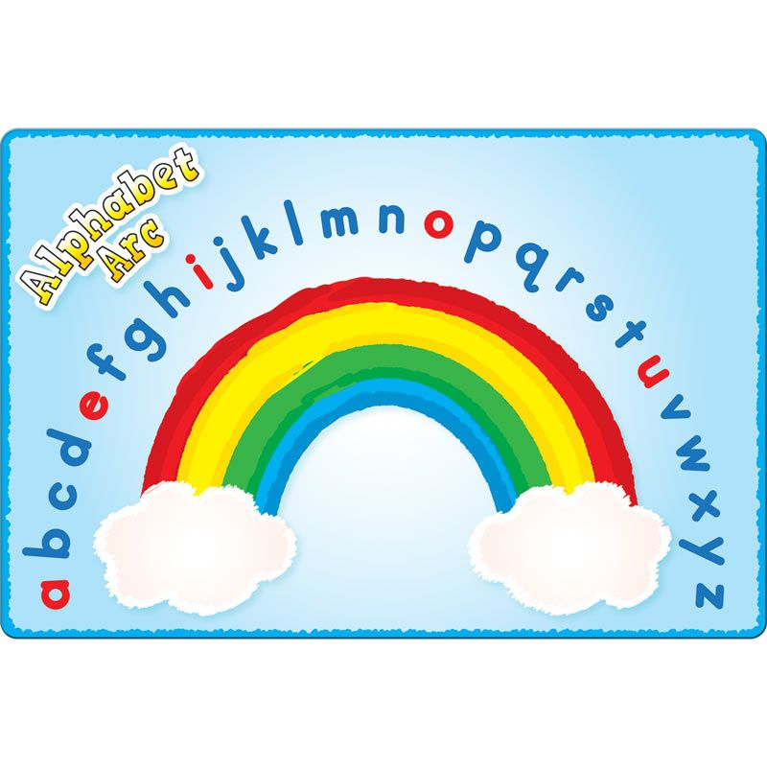
A user friendly guide to support pupils’ knowledge of the alphabet

Ann Worrall and Cathy Fairlie

Magic Letters – The Rainbow Alphabet

How to create your rainbow alphabet…

- Locate letters A, M, N and Z and place them on the alphabet mat, floor or table. This sequence ensures the pupil recognises the beginning, middle and end of the alphabet.
- Build up the letters in alphabetical order in the shape of a rainbow saying the correct letter name.
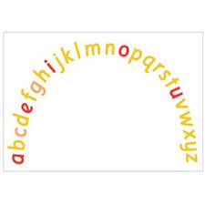
- Pupils can use the rainbow template to check and self-correct letters.

What to do next…

When all the letters are in the correct order the pupil touches each letter as well as simultaneously naming all the letters forwards from A – Z.

Depending on the alphabet knowledge and confidence of the pupil they can then repeat the activity backwards from Z – A.

Pupil and teacher take note of strategies to remember how they identified certain letters.

The teacher can then build up knowledge and properties of the alphabet, eg. number of letters, consonants, vowels and alternative sounds such as short vowels (a in tap) and long vowels (a in tape.)

Other examples could include soft c and g sounds, eg. ice and age and alternative sounds for the letter y, eg. happy and fly.

What is multi-sensory teaching and learning?
Using a multisensory teaching technique means helping a child to learn through more than one sense. A good example of this would involve using a VAK approach (visual, auditory and kinaesthetic.) This caters for all learning styles.

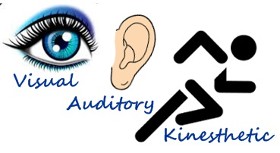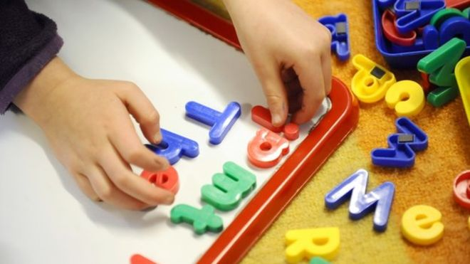

Activities and Ideas
- Pupil closes eyes and points to certain letters
- Take out a letter and guess which letter has been taken out
- Clap every third letter name
- Voice stress every third letter name
- Make cvc, cvcc, ccvc, cccvc words
- Make high frequency words and tricky words
- Make digraphs/trigraphs
- Look at letter patterns
- Play hangman
- Make words using sound boxes with missing letter/sound, eg. circle
- Match lower case with respective upper case letters
- Phonics Activities – cvc words/ onset and rime

Supporting reading
The Rainbow alphabet can also be used to introduce vocabulary for a new book or as part of the walk through. It can also be used for many word activities eg tricky words that cannot be sounded out such as said and was and other common exception words.
A bank of such words is vital in developing fluency in reading and writing.

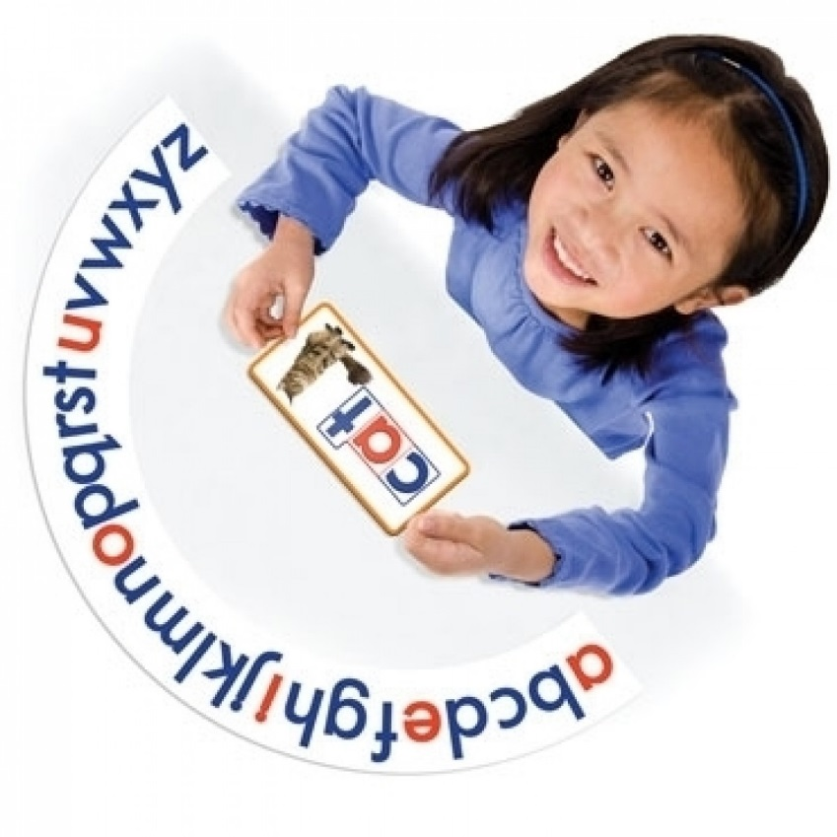

Alphabet Games

Alphabet Sort:
Shuffle a set of alphabet letters (either wooden or printed cards) and ask the pupil to put them into order as quickly as possible. Use alphabet strip to support if necessary.

. 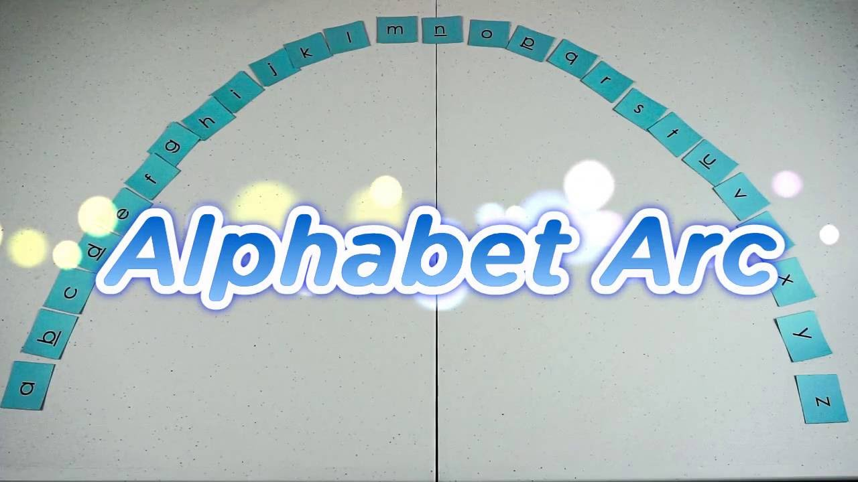

Missing Letters:
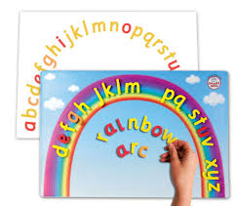

Lay out a set of alphabet letters or cards in alphabetical order. While the pupil closes his or her eyes, take one letter away. Ask the pupil to open his/her eyes and identify the missing letter (a question mark ? card can be used to replace the missing letter). This game can be extended by removing more than one letter. Use alphabet strip to support if necessary.
Letter Reversals:

Lay out a set of alphabet letters in alphabetical order. While the pupil closes his or her eyes, reverse one of the letters. Ask the pupil to open his/her eyes and identify the letter reversal. This game can be extended by reversing more than one letter. Use alphabet strip to support if necessary.

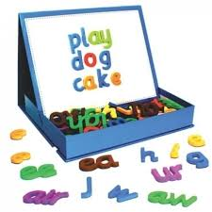

Either Side:

Lay out a set of alphabet cards in alphabetical order. Ask the pupil to turn over one card at a time and identify the letter before/the letter after. This game can be extended by asking the pupil to identify both the letter before and after. Use alphabet strip to support if necessary.

Alphabet Race:

Lay out a set of alphabet letters or cards in a row, either in or out of order. Each player has a counter and a dice. Each player places their counter at the beginning of the row. Player 1 throws the dice and moves along the letters the appropriate number of jumps. Player 1 names the letter that has been landed on (or moves back one space if unable to). Player 2 then throws the dice and moves accordingly. The winner is the first to get to the end of the row. This game can be adapted by asking players to identify letter names/sounds/ words beginning with etc. Use alphabet strip to support if necessary.

Match Up:

Hang a washing line with alphabet cards pegged to the line in order. Pupil to name and match lower case letter to upper case letter.

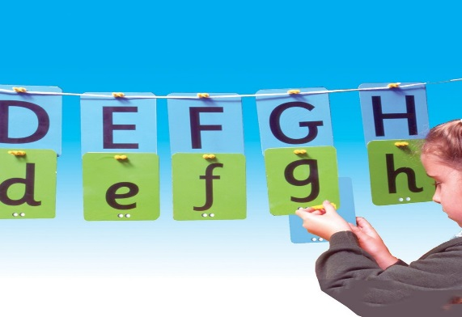
Feely Bag:
Place a selection of letters in a feely bag and ask pupil to identify letters by name.
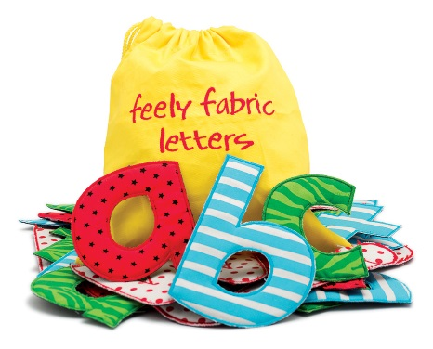
Beyond the arc – what next?

You can now reinforce and extend all these alphabet ideas to support all areas of reading and writing. Have fun…
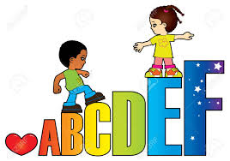

Useful websites and software include:

www.sparklebox.co.uk
www.twinkl.co.uk
www.smartkids.co.uk
www.crossboweducation.com
Letter Olympics ICT software
Word Shark software

