Torkington Primary School Anti - Bullying Policy 
.

Aims & purpose of the policy

At Torkington Primary school we are committed to working with children, staff, governors and parents/carers to create a school community where bullying is not tolerated.

Our school is a place where people have the right to be themselves, to be included and to learn in a safe and happy environment. Everyone at our school is equal and treats each another with respect and kindness.

Bullying of any kind is unacceptable and will not be tolerated at our school. At our school the safety, welfare and well-being of all pupils and staff is a key priority. We take all incidences of bullying seriously and it is our duty as a whole school community to take measures to prevent and tackle any bullying, harassment or discrimination.
We actively promote values of respect and equality and work to ensure that difference and diversity is celebrated across the whole school community. We want to enable our pupils to become responsible citizens and to prepare them for life in 21st Century Britain. These values reflect those that will be expected of our pupils by society, when they enter secondary school and beyond into the world of work or further study.
We are committed to improving our school’s approach to tackling bullying and as such regularly monitor, review and assess the impact of our preventative measures.

We define bullying as:

Bullying is the, wilful, conscious desire to threaten, intimidate or hurt someone, which may be repeated overtime, which involves a real or perceived power imbalance.

School will use professional judgement when considering the behaviour and the context in which it has happened.

Identifying and supporting vulnerable children

We work closely in school to identify particularly vulnerable groups; minority ethnic groups, travellers, refugees, LGBT pupils, midterm arrivals, pupils who transfer late into the school, children or young people in care, young carers, teenage parents and those with other special needs who may find it more difficult to make or sustain friendships.

As a school we plan positive action to support these pupils with all relevant staff members and provide additional support where necessary, for example peer support through buddy schemes and help them access clubs and out of school provision.

Who is bullied?

Anybody could be subject to bullying at any time in their life. It is not only something that affects children and young people.

A person is bullied when, either as an individual or part of a group, she or he suffers in any way from the direct result of intentional and persistent harassment and/or victimisation by another individual or group.

A person who has been bullied may commonly find it difficult to combat victim behaviour or report their experiences to those who may be able to help them.

Below are some factors that can make people vulnerable:

Schools must refer to the Equality Act 2010 and the 9 protected characteristics within it, when dealing with bullying related incidents.

Children and young people who are at most increased risk of being the victims or perpetrators of bullying are those who:

• are in foster care or residential homes (looked after children)
• are understood to be at risk from a range of safeguarding or child protection issues i.e. safeguarding / organised crime groups
• have specific special educational needs (especially on the autistic spectrum)
• have a disability or impairment
• are from minority ethnic backgrounds
• are refugees or asylum seekers
• start a school or activity group mid term
• are, or are perceived to be, gay, lesbian, bisexual, transgender or questioning of their sexuality or gender
• speak a first language other than English
• are young carers
• have suffered bereavement
• have suffered domestic violence
• have experienced physical or emotional trauma
• have a parent that was a victim of bullying.
• experienced poverty or deprivation

Methods of bullying:

There are a number of methods of bullying which can be summarised as:

• Physical aggression – hitting, kicking, tripping up, spitting, taking or damaging property, use of threat or force in any way, intimidation or demands for money or goods
• Verbal – name calling, insulting, teasing, ‘jokes’, mocking, taunting, gossiping, secrets, threats. Reference to upsetting events e.g. bereavement, divorce, being in care

• Non-verbal – staring, body language, gestures

• Indirect – excluding, ostracising, rumours and stories, emails, chat rooms, messaging phones, notes, inappropriate gestures

• Cyber – text messaging, internet chat rooms, the use of social media applications such as Snapchat, Instagram or WhatsApp, the misuse of camera or video facilities (including the self-generated inappropriate images), offensive questions and nasty inbox messages.

• Parental incitement

We acknowledge that some acts of bullying will constitute a criminal offence and in these cases other organisations will need to be contacted e.g. the Police or Social Care

Types of Bullying

There are many different types of bullying including;
• Race (racist bullying)
• Religion or belief
• Culture or class
• Gender (sexist bullying)
• Sexual orientation (homophobic or biphobic bullying)
• Gender identity (transphobic bullying)
• Special Educational Needs (SEN) or disability
• Appearance or health conditions
• Related to home or other personal situation
• Related to another vulnerable group of people

No form of bullying will be tolerated and all incidents will be taken seriously.

Derogatory language

Derogatory or offensive language is not acceptable and will not be tolerated. This type of language can take any of the forms of bullying listed in our definition of bullying. It will be all challenged by staff and recorded and monitored on Red/Yellow card reporting system and follow up actions and sanctions where appropriate. Staff are also encouraged to record the casual use of derogatory language using informal mechanisms such as a classroom log. Staff to report the use of derogatory language through the above school system (by lunchtime every Friday).

Prejudice-based incidents

A prejudice-based incident is a one-off incident of unkind or hurtful behaviour that is motivated by a prejudice or negative attitudes, beliefs or views towards a protected characteristic or minority group. It can be targeted towards an individual or group of people and have a significant impact on those targeted. All prejudice-based incidents are taken seriously and recorded and monitored in school, with the head teacher regularly reporting incidents to the governing body. This not only ensures that all incidents are dealt with accordingly, but also helps to prevent bullying as it enables targeted anti-bullying intervention

Possible indicators of bullying include:

We recognise that the following behaviours may suggest someone is being bullied.
However, we also recognise that the list is not exhaustive.

- disturbed sleep
- bed-wetting
- head and stomach aches
- problems with concentration,
- changes in behaviour and attitude
- truanting
- bullying other children
- damaged or missing clothes / money / property,
- asking for more money than usual or stealing money
- withdrawn or changes in their usual behaviour patterns or attitude
- distressed or emotional and finds it hard to articulate their feelings
- changes in their eating patterns
- changes in their online activity
- shows evidence of self-harming or even for extreme cases potential suicide
- is unusually tired without a reasonable explanation
- has unexplained bruises or marks on their body, (some may refuse to change for PE)
- repeatedly comes to school without dinner money or a packed lunch
- seems afraid to be alone and requires more adult interaction.

School initiatives to prevent and tackle bullying

The following are examples of school initiative undertaken: (Anti-Bullying Week, Black History Month and LGBT History Month)

We use a range of measures to prevent and tackle bullying including:

• The PSHE programme (JIGSAW) of study includes opportunities for pupils to understand about different types of bullying and what they can do to respond and prevent bullying

• School assemblies help raise pupils’ awareness of bullying and derogatory language
• Difference and diversity are celebrated across the school through diverse displays, books and images. The whole school participates in events including Anti-Bullying Week, Black History Month and LGBT History Month. Torkington Primary school uses outside agencies to ensure a deeper understanding of the effects of Bullying through drama projects and cyber bullying projects supported by the local authority, including parent workshops.

• The school values of equality and respect are embedded across the curriculum to ensure that it is as inclusive as possible

• Stereotypes are challenged by staff and pupils across the school

• Pupil-led programmes (Play Leaders) offer support to all pupils, including those who may have been the target of bullying.
• Restorative Approaches and Counsellors (Turn the Page) are available for additional social & emotional support to victims of bullying and those who show bullying behaviour

• Pupils are continually involved in developing school-wide anti-bullying initiatives through consultation with groups for example through the school council or and through the anti-bullying survey

Reporting – roles and responsibilities

STAFF:

All school staff, both teaching and non-teaching (for example midday supervisors, caretakers) have a duty to report bullying, to be vigilant to the signs of bullying and to play an active role in the school’s measures to prevent bullying. If staff are aware of bullying, they should reassure the pupils involved and inform their class teacher.
The following staff members are anti-bullying leads: [Andy Buckler (Headteacher) & Rachel Kempton (PSHE coordinator)

SENIOR STAFF:

The Senior Leadership Team and the head teacher have overall responsibility for ensuring that the anti-bullying policy is followed by all members of staff and that the school upholds its duty to promote the safety and well-being of all young people. In addition to the designated anti-bullying leads, Andy Buckler (HT) Caroline Astall (AHT), Abbie Pietrzak (AHT) are the Senior Leaders responsible for anti-bullying.

PARENTS AND CARERS:

Parents and Carers should look out for potential signs of bullying such as distress, lack of concentration, feigning illness or other unusual behaviour.
Parents and carers should encourage their child not to retaliate, support, and encourage them to report the bullying when it occurs.

We find that it is much more effective to speak to the school direct when an incident occurs and not to post it on social media as this may affect and delay any investigations and outcomes.

Parents and carers can report an incident of bullying to the school either in person, or by phoning or emailing the school office or a member of staff Andy Buckler (andy.buckler@torkington.stockport.sch.uk)
Pupils should not take part in any kind of bullying and should watch out for signs of bullying among their peers. They should never be bystanders to incidents of bullying, but should offer support to the victim and, if possible, help them to tell a trusted adult.

Parents and Carers must also give due regard to and follow the principles of our Respect Charter on school premises towards pupils, staff and other parents

Non-school staff, volunteers and outside organisation (Sports Coaches, etc) also need to be made aware of the schools policy and the reporting of incidents

Dealing with an Incident

When bullying has been reported, the following actions will be taken:

• Staff will investigate and record the bullying on the school’s incident reporting form and also record the incident centrally on central paper recording system/Provision Map

Restorative meetings MUST be held for any incident, which is deemed to be Race or Hate related including homophobic and transphobic incidents)

• Designated school staff will monitor incident reporting forms and information recorded on central paper recording system/provision map analysing and evaluating the results

• Designated school staff will produce termly reports summarising the information, which the head teacher will report to the governing body
• Staff will offer support to the victim with the pupil’s class teacher/ form tutor. Individual meetings will then be held to devise a plan of action that ensures they are made to feel safe and reassured that the bullying is not their fault, this may involve a restorative meeting. Action plans will make use of school initiatives such as playleaders, Turn the Page counselling and lunchtime monitoring

• Staff will pro-actively respond to the perpetrator bully who may require support. They will discuss with the target’s class teacher to devise a plan of action

• Staff will decide whether to inform parents or carers and where necessary involve them in any plans of action

• Staff will assess whether any other authorities (such as Police or the Local Authority) need to be involved, particularly when actions take place outside of school.

Safeguarding procedures must be followed when child protection concerns arise.

Bullying outside of school

Bullying is unacceptable and will not be tolerated, whether it takes place inside or outside of school. Bullying can take place on the way to and from school, before or after school hours, at the weekends or during the holidays, or in the wider community. The nature of cyber bullying in particular means that it can impact on pupils’ well-being beyond the school day. Staff, Parents and Carers, and pupils must be vigilant to bullying outside of school and report and respond according to their responsibilities as outlined in this policy.

School will use their sanctions when it becomes apparent that any incident of bullying is having an impact on an individual and/ or the school community

Training and Awareness

The head teacher is responsible for ensuring that all school staff, both teaching and non-teaching (including midday supervisors, caretakers, outside agencies and volunteers, parents and governors) receive regular training on all aspects of the anti-bullying policy.

Recording and Reporting:

We maintain a system of data collection and analysis in relation to any reported incidents of bullying in school. Termly feedback is made available for governors via the Headteacher report.

All staff will use the agreed reporting format to alert the HT/designated SLT member of any bullying related incidents.

Monitoring and Evaluation:

The head teacher is responsible for reporting to the governing body (and the Local Authority where applicable) on how the policy is being enforced and upheld, via the termly report. The governors are in turn responsible for monitoring the effectiveness of the policy via the termly report, by in school monitoring such as learning walks, and focus groups with pupils.
The policy is reviewed every 12 months, and a committee set up to oversee the review process.

Date of last review: 25/06/2025
Head teacher signed: 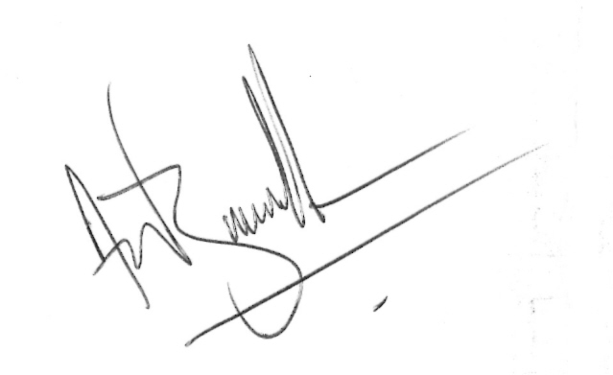
Chair of Governors signed 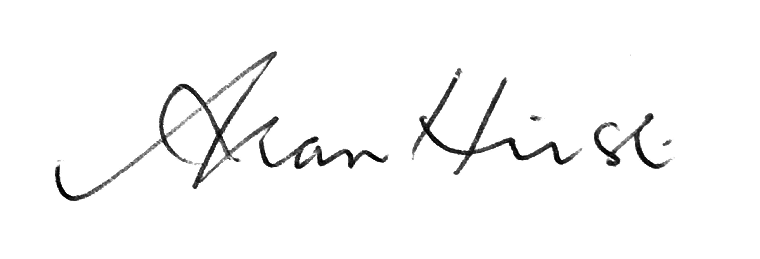

Links to other school policies:

This anti-bullying policy links to a range of policies/strategies, including:

Equalities and Diversity policy
Equality Act 2010
Behaviour policy
Care and control policy
PSHE policy
Peer on Peer Abuse
Respect Policy and Charter
Safeguarding policy
Responsible Use policy
School Development plan
Restorative Approaches strategy

Appendices

- Frequently asked questions
- Stockport’s Anti-bullying Charter
- BSS Audit
- Anti-bullying Checklist for schools
- Organisations that can offer support

Frequently Asked Questions

Q: Should we prioritise tackling some types of bullying over others?
A: Immediate physical safety obviously comes first. All bullying, whatever the motivation or method, is unacceptable and should not be tolerated. Some issues will be more familiar to schools than others and this guidance points to other specialist organisations for further information about how to tackle specific types of bullying. Please see ‘Further Sources of Information’ at the end of this document.

Q: Should we investigate bullying incidents involving our pupils when they occur outside of school?
A: Yes. If an incident of bullying outside the school premises is reported to the school, it is important that it is investigated and appropriate action is taken.

Q: How can we involve parents more in our anti-bullying work?
A: Schools should talk to parents about their anti-bullying policy and make it available to them and prospective parents as part of their behaviour policy. Schools should ensure that parents know what measures are being taken to prevent bullying, as well as how incidents are responded to, and may also encourage positive messages about good behaviour and respect for others at home.

Q: Should I record incidents of bullying?
A: Staff should develop a consistent approach to monitoring bullying incidents in their school and evaluating whether their approach is effective. For some schools, that will mean recording incidents so that they can monitor incident numbers and identify where bullying is recurring between the same pupils.



























































This charter is awarded to

'Bully is willful, conscious desire to threaten, intimidate or hurt someone, which may be repeated over time, which involves a real or perceived power balance.

Our school community will:

• Work with staff, pupils and parents/carers to create a school community where bullying is not tolerated
• Discuss, monitor and review our anti-bullying policy every two years

• Keep a high profile in and around school to prevent bullying behaviours developing

• Support staff to promote positive relationships and identify and tackle bullying appropriately

• Investigate incidents of bullying and take action where necessary, supporting individuals at all times
• Ensure that pupils are aware that all bullying concerns will be dealt with sensitively and effectively so that pupils feel safe to learn and that pupils abide by the anti-bullying policy

• Report back quickly to parents/carers regarding any concerns on bullying and deal promptly with complaints. Parents/carers in turn will work with the school to uphold the anti-bullying policy
• Learn and share good practice and utilise the support of the Local Authority and other agencies where appropriate

Chair of Governors: Headteacher: Representative of pupils:

Date:
Appendix 2 - A self-review tool for challenging bullying in schools




A self review tool for challenging bullying in schools

The following procedure can be used to gather evidence for the individual checklists then to create an anti-bullying action plan:

- Schools to make a floor plan of their school including grounds and leaving a space for outside school grounds.
- Teachers distribute one floor plan to each child.
- Teachers discuss the terms ‘unsafe’ and ‘safe’ with groups and what this means. Also discuss feelings associated with feeling like this.
- Children put a red dot on the plan for everywhere they feel unsafe and a green dot for everywhere they feel safe. Also put a red outside grounds if they feel unsafe anywhere on the way to or from school.
- Teachers to collate areas of concern within their own group discuss the reasons for this unsafe feeling and fill in the individual group self -review checklists (example pro forma following).
- In a staff meeting all staff collate individual audits and record action to be taken and when. (example pro forma following).

Individual group Anti-bullying Audit

Group:
Teacher:
Date:

Area of Concern | Reasons given for concern

Whole school Anti-bullying Audit & Plan
School:
Antibullying lead:

Area of Concern | Reasons given for concern | Action to be taken | Date for action to be in place | Impact/Evaluation

Anti-bullying checklist for schools–

Issue | Evidence | In place | Partly in place | Not in place | Action
POLICY
A clear definition of bullying is included in our school policy
The definition of bullying is clearly understood by:
Staff
Children and young people
Parents/Carers
Governors
Our anti-bullying policy is in place and makes clear reference to:
Faith based bullying
Racist bullying
Homophobic & transphobic bullying
Cyber-bullying
Disability based bullying
Policy is reviewed bi-annually by Governing Body in consultation with school community
We have a Governor (or group) with a nominated responsibility for anti-bullying
Policy is communicated effectively to the school community using a range of methods eg: the school website, posters, newsletter, leaflets, logos around school
DEALING WITH INCIDENTS
Children and young people are clear about how to report bullying in our school
Children and young people are confident to report bullying in school
We have clear structures in place which identify who deals with incidents of bullying that emerge in school
We have clear mechanisms in place for recording incidents of bullying
Records of bullying incidents include the support provided to:
The victim(s)
The bully
The Governors in our school are aware of incidents via reports from the HT
Our school includes restorative approaches in its toolkit to address bullying behaviour
Our school provides access to self-help resources for children and young people
Our school provides peer to peer support e.g.: playground buddies, peer mentoring etc.
Our school takes care to ensure that the improvement for the victim is sustained
Where necessary our school calls upon other services to support children (both the victim and the bully) involved in incidents, and may use CAF/TAC where appropriate
PREVENTION
Our school challenges all verbal comments that could underpin a culture of bullying including:
Racist language
Homophobic language
Discriminatory language
We specifically teach sessions around:
Cyberbullying
Homophobic bullying
Racist bullying
Faith based bullying
Disability based bullying
(consider the following as options)
- Delivering SEAL
- PSHE
- Assemblies
Our commitment to the anti-bullying agenda is visible to our whole school community for example:
- The website
- Posters displayed around school
- References in newsletter
- Anti-bullying charter
Participate in national programmes eg: Anti-Bullying week.

